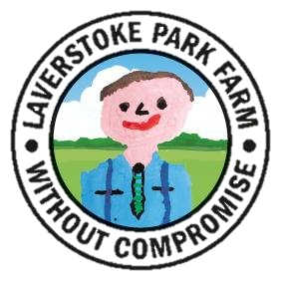
JOB TITLE: Tractor Driver | REPORTS TO: James Cranham- Ryder,  Farm Manager
SALARY: Dependent on experience

OUR COMPANY:

We are looking for an enthusiastic, reliable and motivated individual to join the friendly farm team. The successful applicant will be one who enjoys the outdoors and isn’t afraid to turn their hand to whatever duties are required for the farm to run efficiently.

At the heart of Laverstoke, and feeding off acres of lush organic pastures, is our large herd of Asian water buffalo, native angus and sheep. Specialising in the care of diverse and rare breeds, this is an exciting and unique position.

We are located in 2,500 acres of beautiful Hampshire countryside. A stunning place to work, with hard-working people working together to create a profitable company, in a great environment, producing exciting, award winning products.

We strongly believe in the ‘field to fork’ philosophy, and invite you to join our great team, caring for our animals and land!

THE ROLE:
- Carrying out a large variety of tractor driving and machine operating using up-to-date New Holland tractors
- Responsible for all cultivation and drilling work
- Upkeep and tidying of the farm
- Machinery Maintenance
- Assisting the farm manager with daily farm duties, where required
- Some livestock work when required
THE INDIVIDUAL:
- Have previous experience in this type of role
- Good communication skills
- Be enthusiastic, motivated, honest, reliable and trustworthy
- Have a practical/ hands on attitude
- Take initiative as well as working well as part of team
- Be flexible with working hours
- No formal qualifications are required
- Telehandler experience and accreditation desired

If you have any additional questions regarding the role, please contact recruitment@laverstokepark.co.uk, where a member of our team will be more than happy to assist you.

