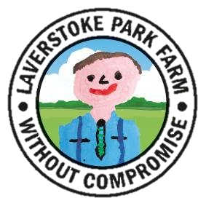
JOB TITLE: Herdsman/ Herdswoman | MANAGER: James Cranham- Ryder,  Farm Manager  REPORTS TO: Tim Thompson, Dairy Manager
SALARY: Dependent on experience

OUR COMPANY:

We are looking for an enthusiastic, reliable and motivated individual to join the farm team. The successful applicant will be one who enjoys the outdoors and is comfortable working with large animals.

At the heart of Laverstoke, and feeding off acres of lush pastures, is our large herd of Asian water buffalo, native angus and sheep. Specialising in the care of diverse and rare breeds, this is an exciting and unique position.

We pride ourselves on the great care we provide our animals. Every attention is paid to the animal’s welfare; no growth promoting hormones are used, to any animal bearing the quality assured seal of Laverstoke Park.

We are located in 2,500 acres of beautiful Hampshire countryside. A stunning place to work, with hard-working people working together to create a profitable company, in a great environment, producing exciting, award winning products.

We strongly believe in the ‘field to fork’ philosophy, and invite you to join our great team, caring for our animals and land!
THE ROLE AND RESPONSIBILITIES:
- You will be contributing to the health and well-being of the animals on the farm, including milking and feeding buffalo, husbandry and other associated land work.
- General farm maintenance, including fencing.
- Candidates must be flexible with regard to shift/ start time, and able to work on a rota system due to the increase in production
THE INDIVIDUAL:
- Good communication skills
- Applicants must have a knowledge of livestock handling with some experience of general farm work
- Be enthusiastic, motivated, honest, reliable and trustworthy
- Have a practical/ hands on attitude
- Take initiative as well as working well as part of team
- Be flexible
- No formal qualification is required
- Telehandler & tractor experience and related accreditation an advantage

If you have any additional questions regarding the role, please contact recruitment@laverstokepark.co.uk, where a member of our team will be more than happy to assist you.

